CHAPTER 4
IMPLEMENTATION

4.0 Introduction
This chapter presents the implementation and user guide for the HomeEase web application, a digital platform designed to connect households with domestic service providers. It provides a detailed explanation of the system interface and step-by-step instructions for users, service providers, and administrators.Finally, this chapter serves as a thorough user manual, providing detailed step-by-step instructions for every feature of the platform, guiding service providers, service seekers, and administrators through each process with accompanying interface screenshots.

4.1 Implementation Environment
The implementation environment consists of the specific hardware components and software development tools utilized to build, compile, and test the mobile application. Establishing a robust environment ensures that the application is scalable, maintainable, and performs optimally across different devices.

4.3 System Interface and User Manual
This section provides a comprehensive step-by-step user manual for the HomeEase web application . It is designed so that any user, whether a service , driver, or administrator, can follow the instructions to operate every feature of the application independently. The instructions are organised by user role, with each process broken down into numbered steps accompanied by references to the relevant application screenshots.

4.3.1 Getting Started
This subsection covers the processes common to all users(service seekers and service providers), account creation, and authentication.

4.3.1.1 Accessing the Website
- Open a web browser on your computer or phone
- Visit the HomeEase platform ( https://home-ease-phi.vercel.app)
- The homepage will load with options to Sign in or Get started


Figure 4.1: HomeEase Landing Page -and Features Overview

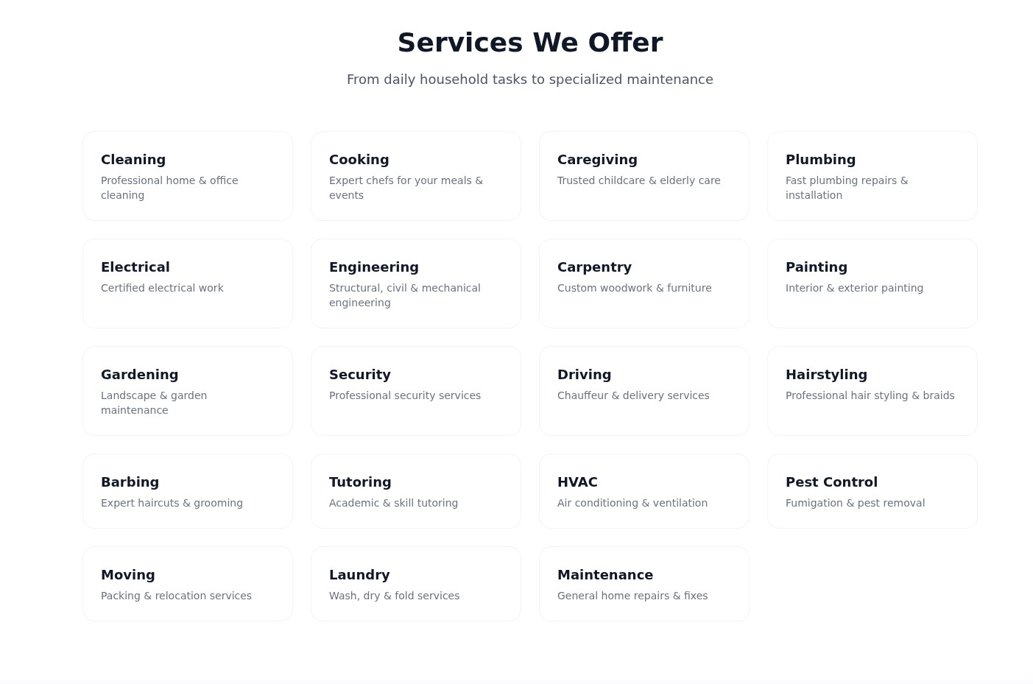

Figure 4.2: HomeEase Features Overview

4.3.1.2 Creating an account
- Click on Get Started
- Select your role:
  - Service Seeker
  - Service Provider
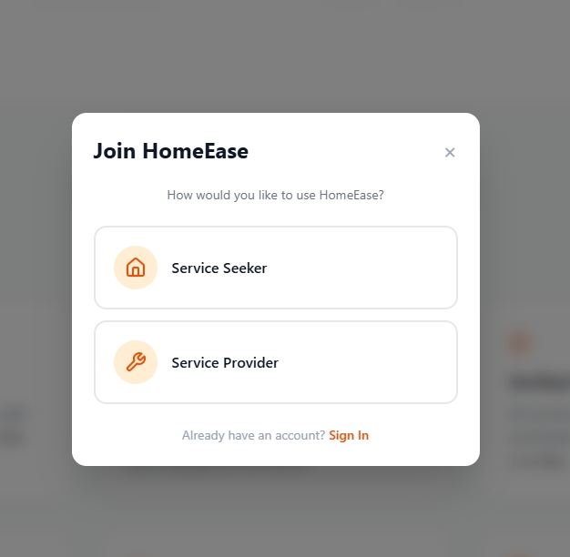

Signing Up As a Service seeker:
• Click on Service seeker button.
• Fill in the registration form:
- Full Name
- Email Address
- Phone Number
- Password
- Confirm Password
Click on the “sign Up button”
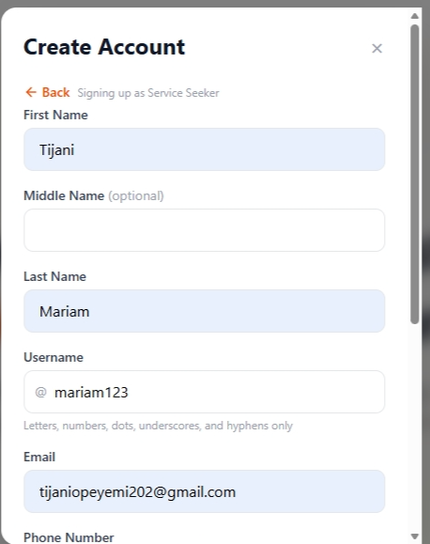
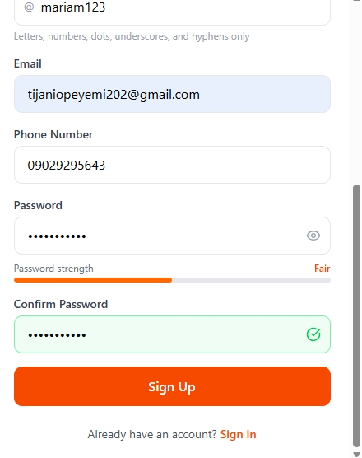
Signing up as a Service provider
- Click on “Service provider” button.
- Fill in the registration form:
- Full Name
- Email Address
- Phone Number
- Bio
- Bank Details
- Password
- Confirm Password
- Click on the “Sign Up” button

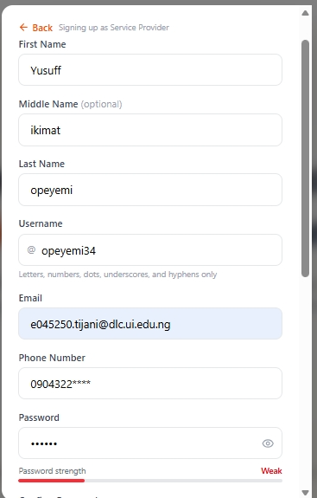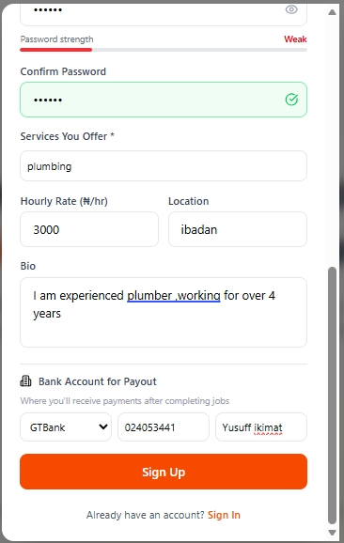

Signing In as a service seeker
- Click on “Sign in” on the Homepage
- Enter your email or username or Phone number and password.
- Click “Sign In” to access your dashboard.
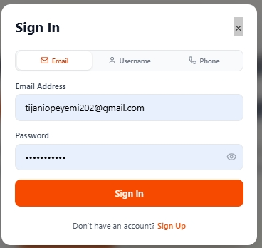

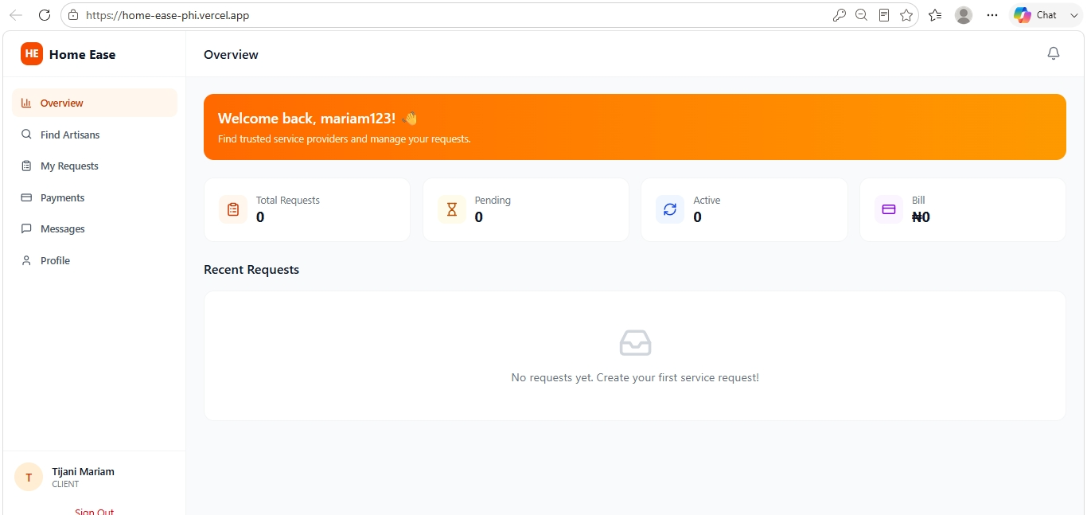

Booking for a service provider(Artisan)
1. On the provider seeker dashboard, go to find artisans
2. Click on ”Find artisans”
3. Search for desired Service e.g cooking, plumbing, caregiving etc
4. click on “Book Now”
5. Fill in Booking details:
- Location
- Date
- Time
6. Click on “Confirm Booking”
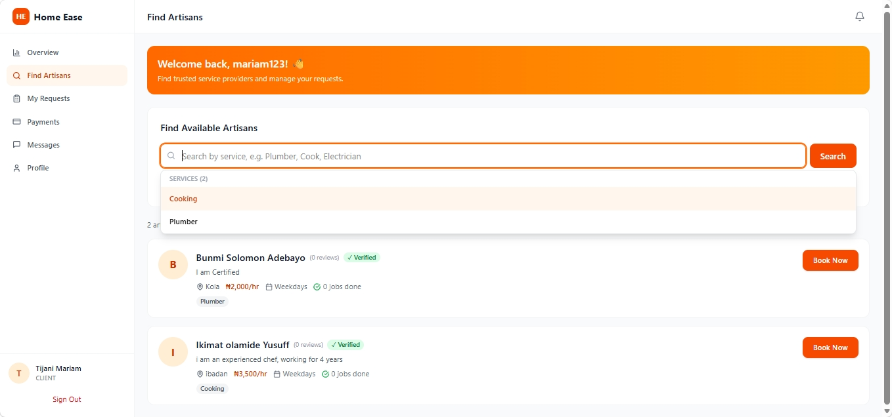

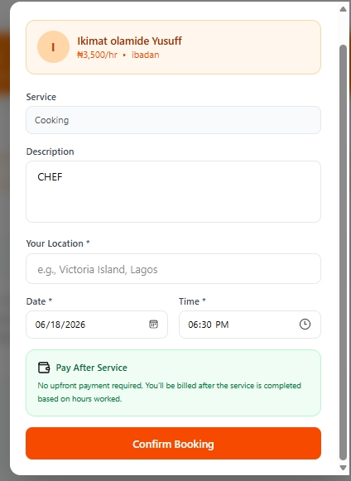

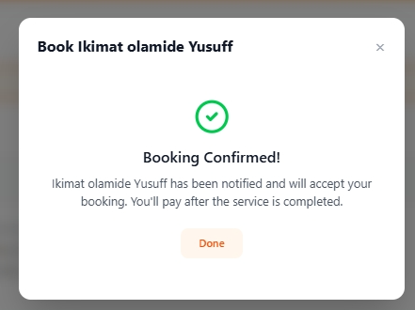

Service provider Manual
- Sign in using ,email ,phone number or u

- sername.
- Enter your password
- Click on ”Sign in” button
After signing in as a service provider, the servicer provider page opens
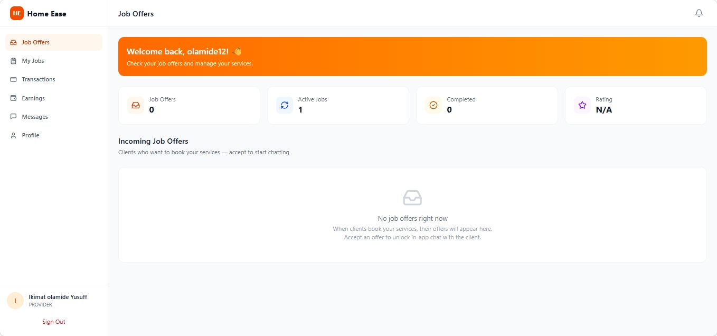

How to accept Job offers
- Click on “Job offers” on the Page
- Check for any request for your services
- If there is any, “accept’ or “reject’ offer.

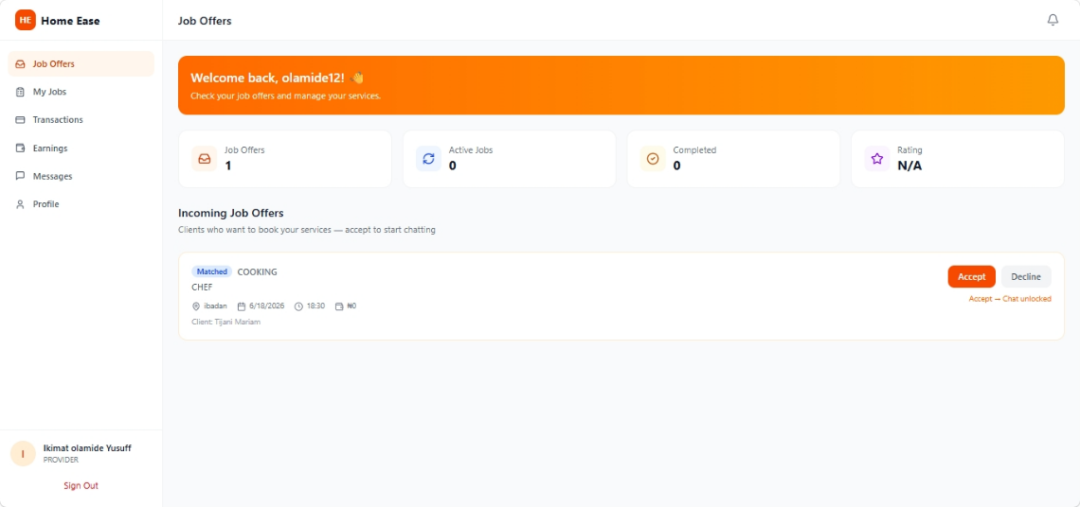

Checking-in After accepting Offer
After a service provider accepts offer, when he or she gets to the service seeker house and there is no complaint. The service provider has to click on “check-in” to get work started and the time starts to read.
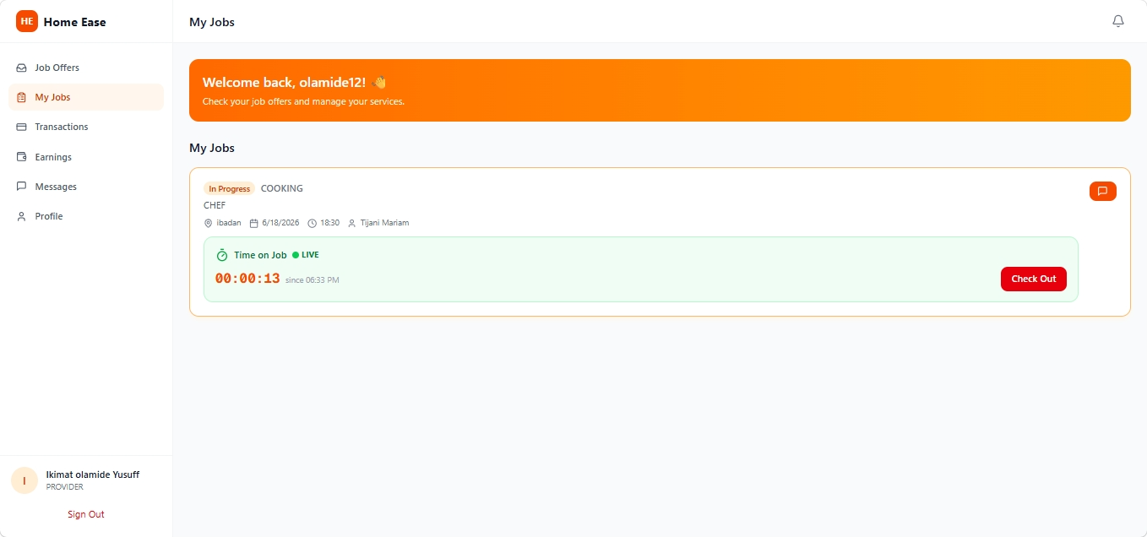

Checking-out after work is completed
When work is completed the service provider has to click on “ check-out” and await payment.

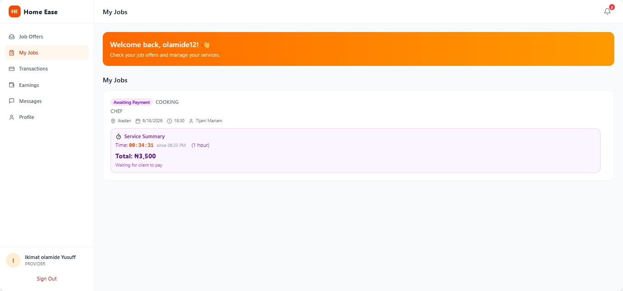

Making payment after work is completed
After checking out by a service provider ,the service seeker has to check the work done and if everything is in order
If the service seeker is satisfied ,he or she proceeds to make payment.
The service seeker signs in:
1.click on “My requests”

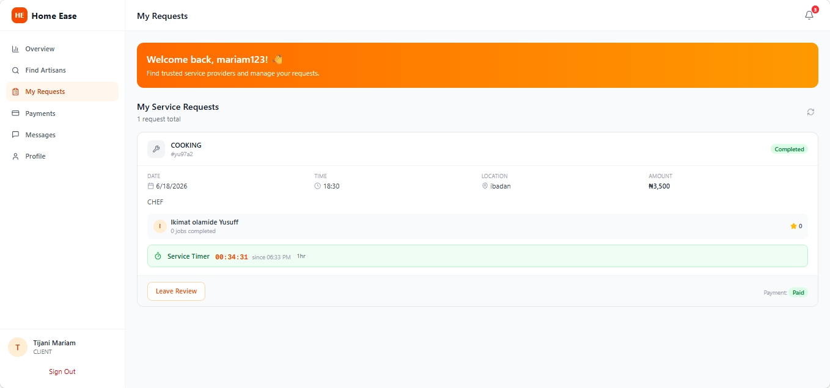

Figure 4.20: My Reports Screen (filter pills and status badges)

4.3.2.14 Using the AI Chatbot for Support
- From the Profile tab, tap “Help”.
- The Help & Support screen will open with two tabs: FAQ and Chat with AI.
- Tap the “Chat with AI” tab.

4. You will see a welcome message: “Hi! I'm your UI-Ride support assistant. How can I help you today?”
- Tap any quick question chip (e.g., “How do I request a ride?”, “How does payment work?”) to ask a common question instantly.
- To ask a custom question:
  - Type your question in the text input field at the bottom.
  - Tap the send button (arrow icon).
  - The text “Assistant is typing...” will appear while the AI processes your question.
  - The AI's response will appear as a message bubble on the left side of the chat.
- You can continue the conversation by asking follow-up questions.
Note: The chat history is maintained within the current session. If you leave the Help screen and return, the chat will start fresh.
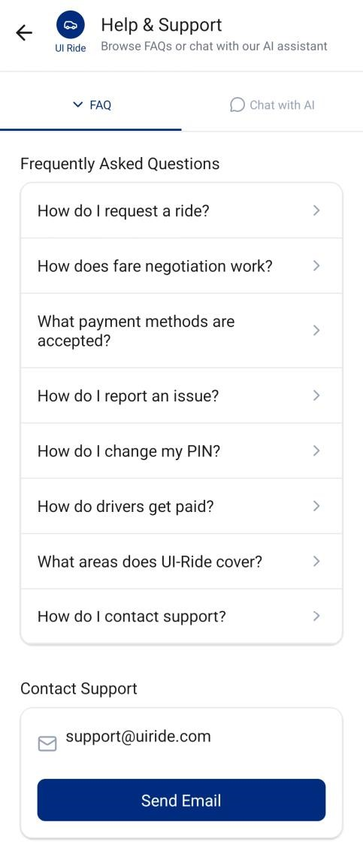 | 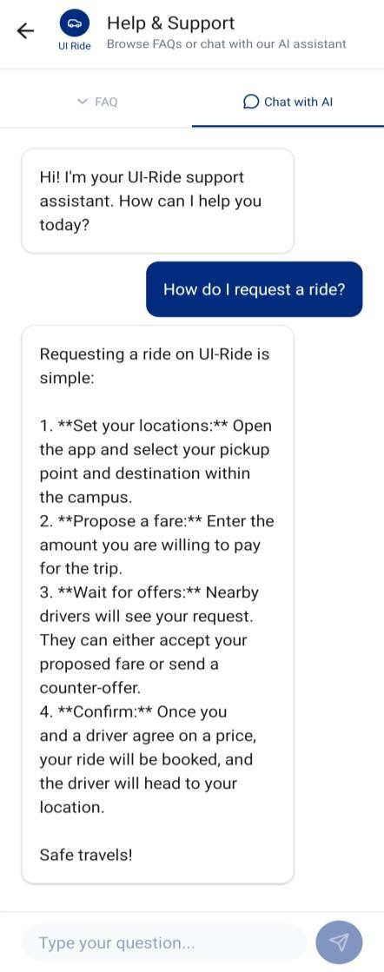

Figure 4.21: FAQ and Chatbot Screens

4.3.2.15 Managing Your Profile
- Tap the “Profile” tab in the bottom navigation.
- Your profile screen displays:
  - Profile photo (tappable to edit) with a small edit overlay icon.
  - Your name and phone number.
  - Your total trip count.
- Below your info, menu items are available:
  - Edit Profile: Update your name, email, and profile photo.
  - My Reports: View all your submitted incident reports.
  - Security Settings: Change your PIN or manage fingerprint login (see Section
4.3.2.16).
  - Help: Access FAQ and AI chatbot support.
- At the bottom, the red “Log Out” button signs you out and returns you to the Welcome Screen.

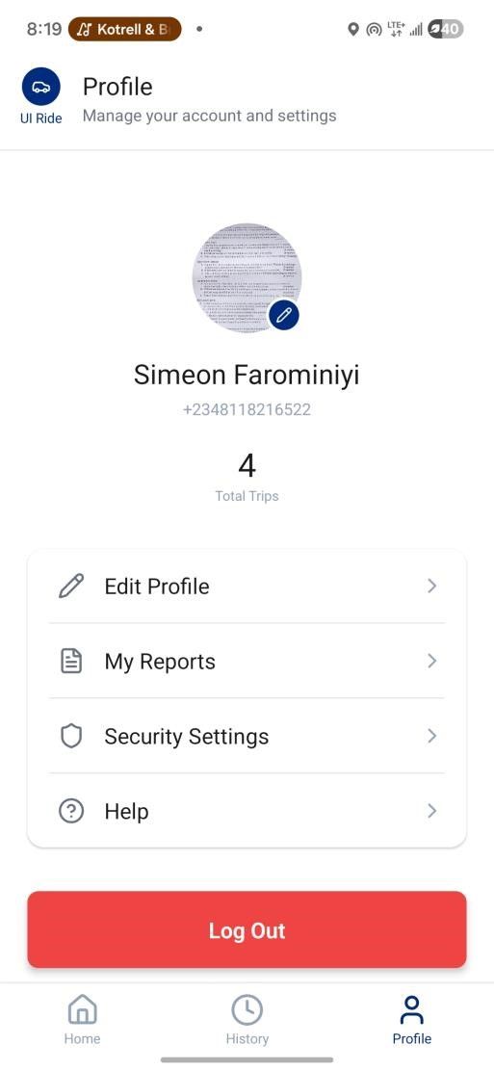

Figure 4.22: Passenger Profile Screen

4.3.2.16 Managing Security Settings
The Security Settings screen allows you to change your PIN or manage fingerprint login at any time.
- From the Profile tab, tap “Security Settings”.
- To change your PIN:
  - Tap “Change PIN”.
  - Enter your current 6-digit PIN.
  - Enter your new 6-digit PIN.
  - Re-enter the new PIN to confirm it.
  - Tap “Save”. Your new PIN will be stored securely on the device and updated in the system.
- To enable or disable fingerprint login:
  - Tap the toggle next to “Fingerprint Login”.
  - When enabling: your device's fingerprint scanner will activate. Scan your registered finger to verify and activate the setting.
  - When disabling: the toggle turns off immediately. You will need to enter your PIN on subsequent logins.
Note: Fingerprint settings are stored per device and are not synced across devices. The “Fingerprint Login” option will only appear if your device has a compatible fingerprint sensor with enrolled fingerprints.
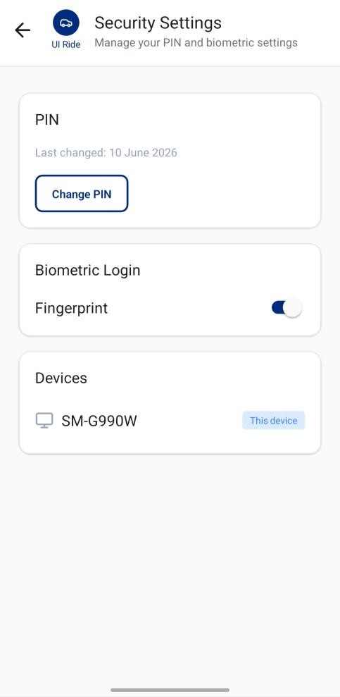

Figure 4.23: Security Settings Screen (PIN change and fingerprint toggle)

4.3.3 Driver User Manual
This subsection provides detailed instructions for all features specific to drivers.

4.3.3.1 Completing Driver Registration
After signing up as a driver, you must complete the vehicle registration form before you can go online.
- After signup, you will be automatically navigated to the Driver Registration screen.
- Complete the form across three sections:
Section A: Vehicle Information
  - Select your Vehicle Type by tapping one of three cards: Car, Tricycle, or Bus.
  - If you selected Car, additional fields will appear:
    - Make: e.g., Toyota
    - Model: e.g., Camry
    - Year: e.g., 2020 (4-digit number)
- Enter the vehicle Color (e.g., Black).
- Enter the Plate Number (e.g., ABC-123-XY). The field auto-uppercases your input.
- Upload 1 to 3 Vehicle Photos by tapping the photo upload area and selecting images from your gallery.
Section B: Driver License
  - Enter your License Number (auto-uppercased).
  - Enter the License Expiry Date by typing the date in YYYY-MM-DD format. The input auto-formats as you type (e.g., typing “20251231” becomes “202512-31”).
  - Tap the upload button to upload your License Front photo.
  - Tap the upload button to upload your License Back photo.
Section C: Bank Account
  - Enter your Bank Name (e.g., First Bank).
  - Enter your 10-digit Account Number.
  - Enter the Account Holder Name.
  - Select your Payout Preference:
    - Daily: Your earnings will be processed for payout every day.
    - Weekly: Your earnings will be processed for payout every 7 days.
- After filling all required fields, tap the “Complete Registration” button. All photos will be uploaded and your details will be saved.
- Your account status will remain “pending” until an administrator reviews and approves your registration.
Important: You will see a dark amber banner on your Home Screen: “Account Pending Verification - Your account is being reviewed by admin. You'll be able to go online once approved.” You cannot accept rides until the administrator approves your account.

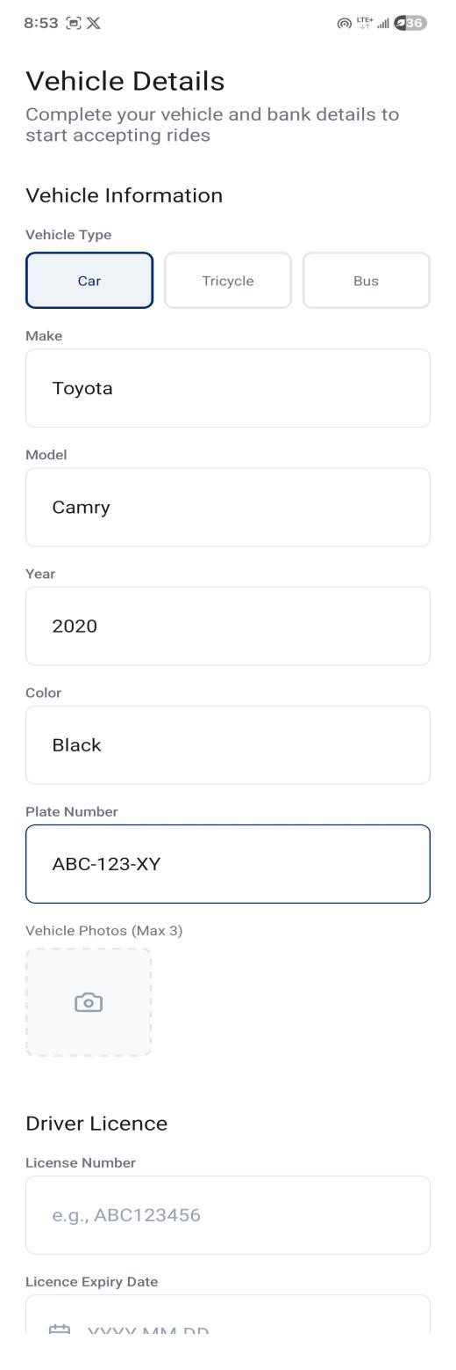 | 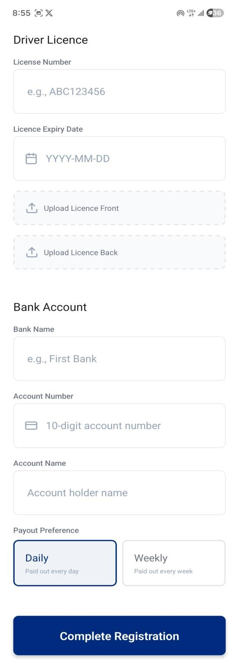

Figure 4.24: Driver Registration Screens

4.3.3.2 Understanding the Driver Home Screen
After your account is approved by an administrator, you can access the full Driver Home Screen. This is what you will see:
- A full-screen map showing your current location.
- A top overlay bar with:
  - Online/Offline toggle button: Gray when offline, green when online. Tap to switch your availability.
  - Today's stats: Your trip count and total earnings for the current day (e.g., “2 trips today - ₦1,200”).
- Status banners (displayed when applicable):
  - Amber banner: “Account Pending Verification”: Your registration is under review.
  - Red banner: “Account Suspended”: Your account has been suspended by an administrator.
  - Registration banner: “Complete your registration to go online” with a “Register” button.
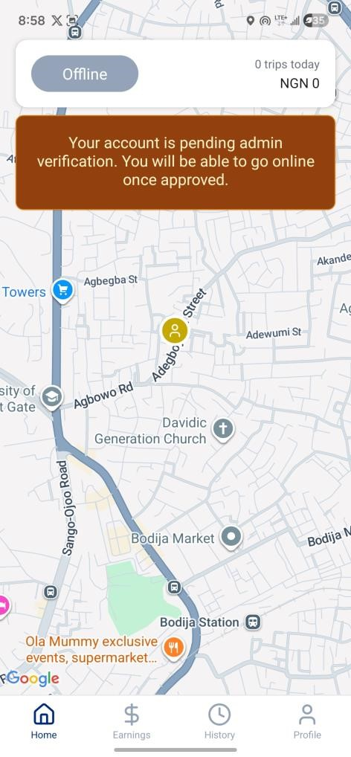 | 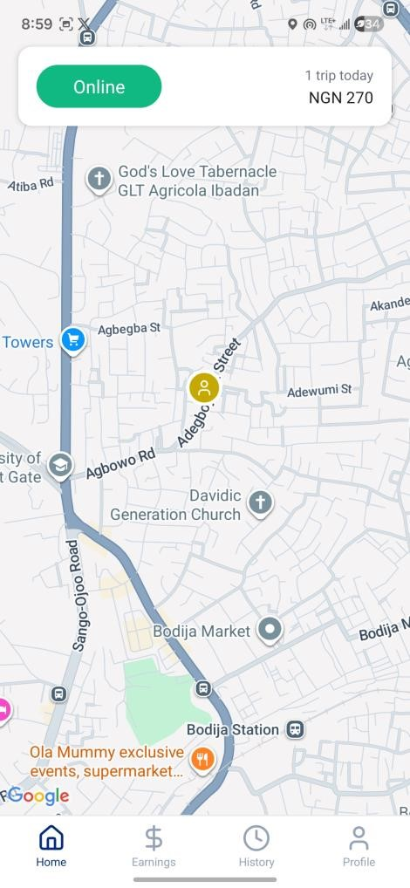

Figure 4.25: Driver home screen (Online) and with pending verification banner

4.3.3.3 Going Online and Receiving Ride Requests
- On the Driver Home Screen, tap the Online/Offline toggle button (currently gray, showing “Offline”).
- The button will turn green and display “Online”. Your GPS location will start being shared with the platform every 5 seconds, and you will appear as an available driver on passengers' maps.
- When a matching ride request is detected (within 5km of your location), a Ride Request Modal will slide up from the bottom with phone vibration.

The Ride Request Modal displays:
- “New Ride Request” heading with a 60-second countdown timer.
- Passenger count.
- Pickup address (green map pin icon) and destination address (red flag icon).
- The passenger's proposed fare.
- Distance to pickup in kilometers.
- Required vehicle type badge (if the passenger specified one).
- A counter-offer input field with placeholder “Enter your price”.
- Three action buttons:
  - “Accept at Proposed Fare”: Accepts the ride immediately at the passenger's offered price. You will navigate to the Active Ride screen.
  - “Submit Own Bid”: Sends your counter-offer to the passenger. You must type an amount in the counter-offer field first. A success toast will confirm the bid was sent.
  - “Decline”: Skips this ride request. The modal will close and this request will not appear again.
Note: If you do not respond within 60 seconds, the request is automatically declined.
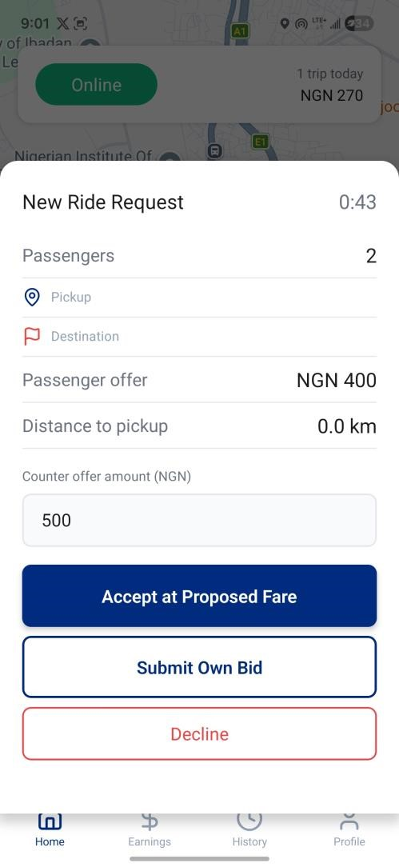

Figure 4.26
:
Ride Request Modal

4.3.3.4 Managing an Active Ride
After accepting a ride, the Driver Active Ride screen guides you through the entire trip lifecycle in three phases.
Phase 1: Heading to Pickup
- The map shows a route line from your current location to the pickup point.
- The screen displays the passenger's name, pickup address, destination address, and agreed fare.
- Available actions:
  - “Call Passenger”: Opens your phone dialer.
  - “Arrived at Pickup”: Tap this when you reach the pickup location. The passenger will receive a notification.
  - “Cancel Ride”: Available before the trip starts.
Phase 2: Waiting for Passenger
- The status label changes to amber after you tap “Arrived at Pickup”.
- Available actions:
  - “Call Passenger”: To contact the passenger if they are not yet at the pickup point.
  - “Start Trip”: Tap this once the passenger has boarded your vehicle.
  - “Cancel Ride”: Still available at this stage.
Phase 3: Trip in Progress
- The status label changes to green after you tap “Start Trip”.
- The route line now points from your location to the destination.
- Available actions:
a. “Complete Trip”: Tap this when you have arrived at the destination. The passenger will be notified and you will be taken to the Payment Collection screen.
- The “Call Passenger” and “Cancel Ride” buttons are hidden during the active trip.
Note: The red SOS button is available throughout all three phases of the ride.
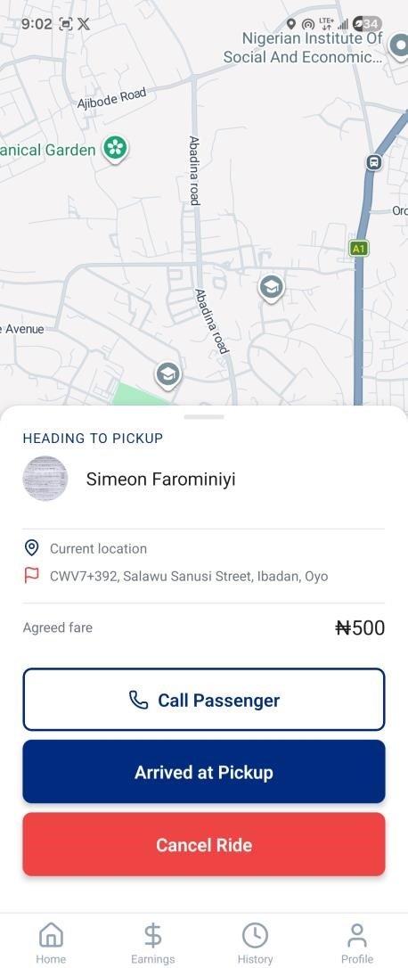 | 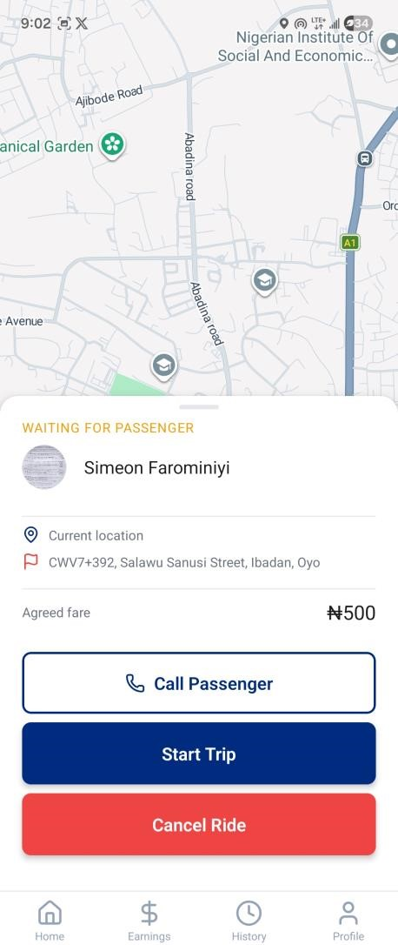

Figure 4.27: Heading to pickup and waiting for passenger screens
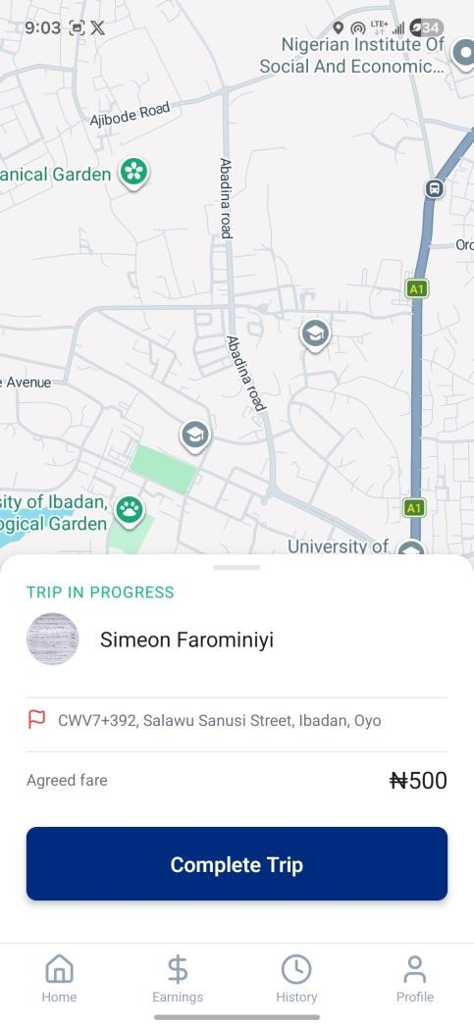

Figure 4.28
:

Trip in p
rogress
screens

4.3.3.5 Collecting Payment
After completing a trip, you will be automatically navigated to the Payment Collection screen. The screen displays a status icon and message that updates automatically based on the passenger's action:
- Clock icon - “Waiting for Passenger”: The passenger has not yet selected a payment method.
- Credit card icon - “Passenger Paying by Card”: The passenger is processing a card payment. No action is required from you; this screen will update automatically when the payment succeeds.
- Banknote icon - “Cash Payment Selected”: The passenger has chosen to pay with cash.
- Check circle icon - “Payment Complete!”: Payment has been confirmed.
A fare breakdown card shows:
- Gross Fare: The total agreed fare.
- Commission (10%): The platform's cut, shown in red (e.g., “-₦50”).
- Your Earnings: The net amount you receive, shown in green (e.g., “₦450”).
To confirm a cash payment:
- Wait until the status changes to “Cash Payment Selected”.
- Collect the cash from the passenger.
- Tap the “Confirm Cash Received” button.
- A dialog will appear: “Has the passenger paid ₦[amount] in cash?” Tap “Yes, Confirm” or “No” to cancel.
- After confirmation, the screen will show “Payment Complete!”. Tap the “Done” button to return to the Driver Home Screen.

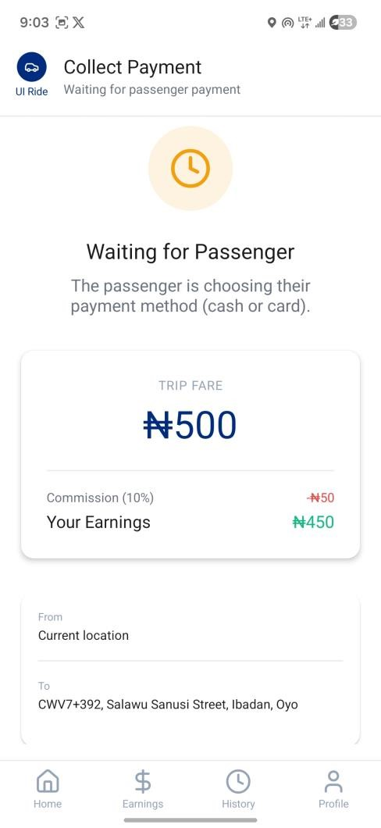 | 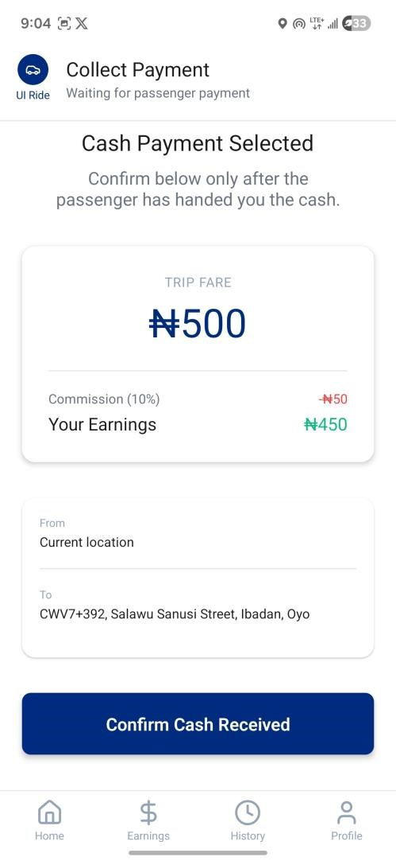

Figure 4.29: Payment collection screens
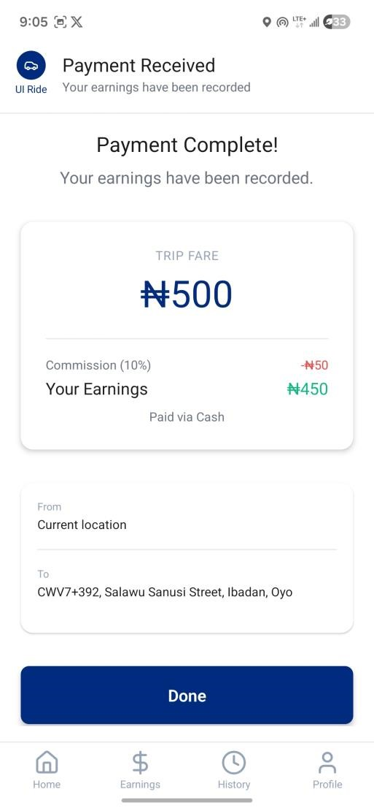

Figure 4.30: Payment complete with Done button

4.3.3.6 Viewing Your Earnings
- Tap the “Earnings” tab in the bottom navigation.
- The Earnings screen displays:
  - Summary cards: Total earnings for Today, This Week, and This Month.
  - Stats pills: Today's trip count and pending payout amount.
  - Payout Info card: Your payout preference (Daily/Weekly), pending payout amount, commission rate (10%), and an explanation of when payouts are processed.
  - Recent Earnings list: Your last 5 earnings showing passenger names, dates, amounts, and payment method badges (Cash/Card).
- Tap “View All” to see your complete earnings history with period-based filtering (Today, This Week, This Month).

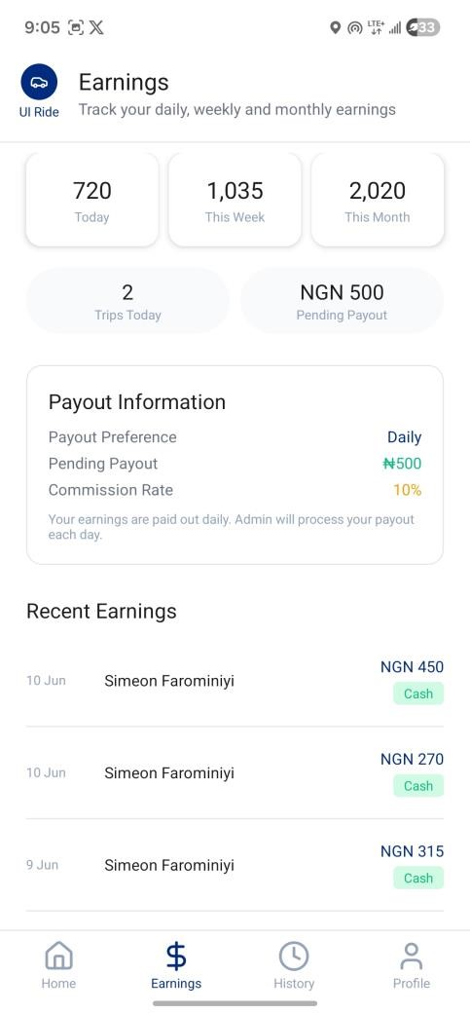 | 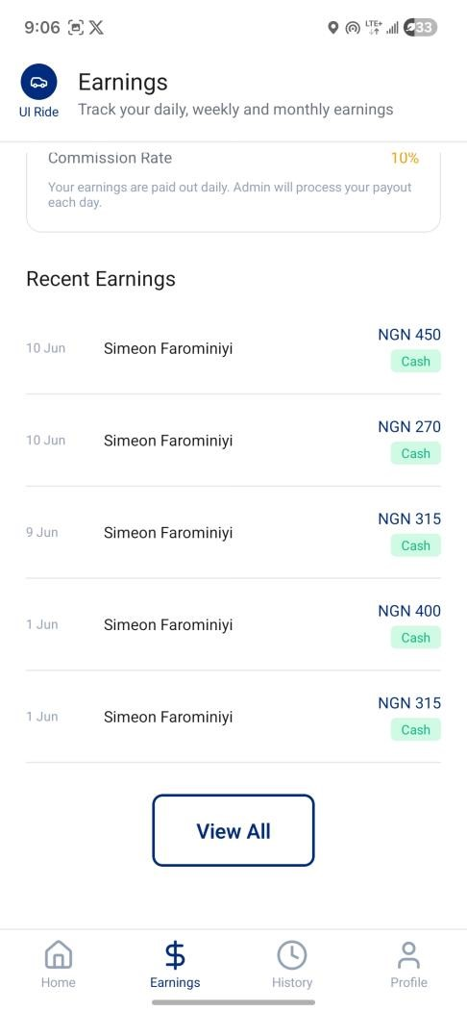

Figure 4.31: Driver Earnings Screen

4.3.3.7 Viewing Your Trip History
- Tap the “History” tab in the bottom navigation.
- Your trip history is displayed with passenger names, dates, pickup and destination addresses, fare amounts, and payment or cancellation badges.
- Tap any trip card to open the full Ride Details screen for that trip.
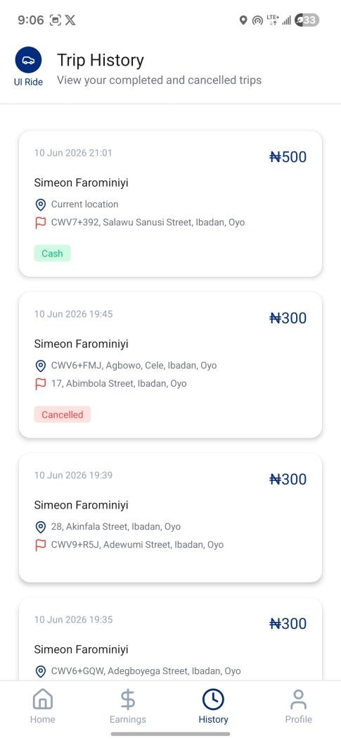 | 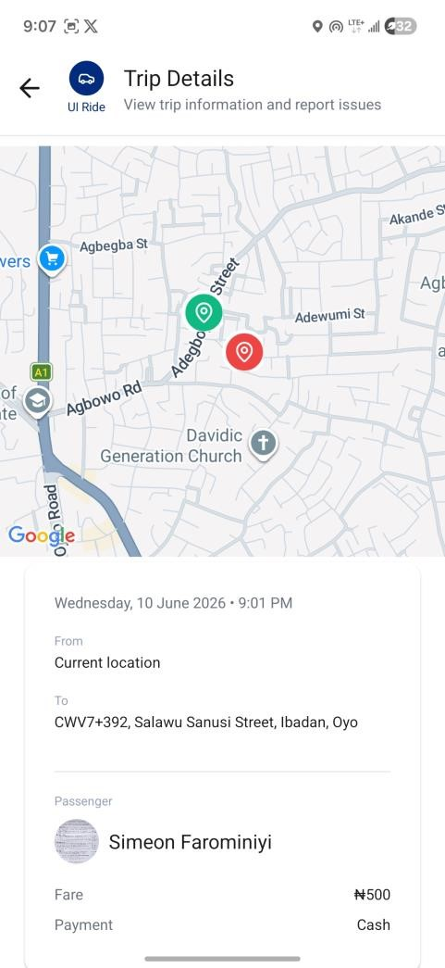

Figure 4.32: Driver trip history screen

4.3.3.8 Managing Your Driver Profile
- Tap the “Profile” tab in the bottom navigation.
- Your profile displays:
      - Profile photo, name, and phone number.
      - Star rating and total ratings count.
      - Total trip count.
      - Vehicle card showing your registered vehicle details (type, make, model, color, plate number).
- Menu items available:
  - Edit Profile: Update personal info and photo.
  - Reports Filed Against Me: View any incident reports submitted about you by passengers.
  - Security Settings: Change PIN or manage fingerprint login (see Section
4.3.3.9).
  - Help: Access FAQ and AI chatbot.
- Tap the red “Log Out” button at the bottom to sign out.

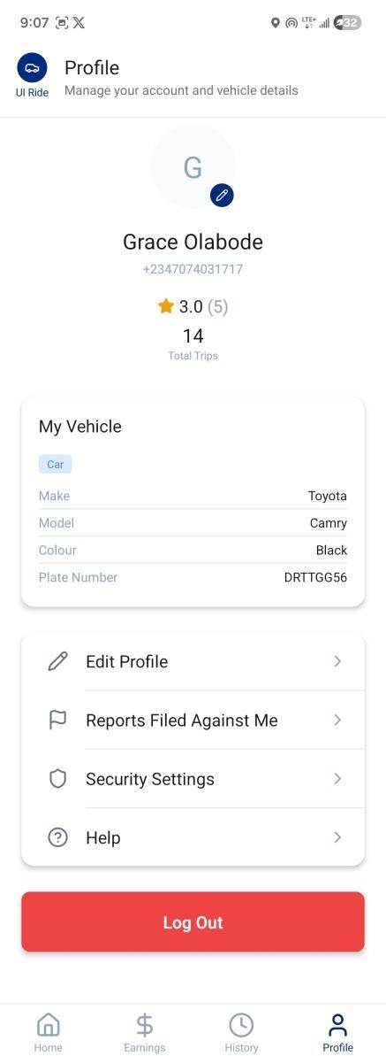

Figure 4.
3
3
:
Driver
Profile Screen

4.3.3.9 Managing Security Settings
The Security Settings screen allows drivers to change their PIN or manage fingerprint login at any time. The process is identical to that described for passengers in Section 4.3.2.16.
- From the Profile tab, tap “Security Settings”.
- To change your PIN: Tap “Change PIN”, enter your current PIN, enter a new 6-digit PIN, confirm it, and tap “Save”.
- To enable or disable fingerprint login: Tap the fingerprint toggle. When enabling, scan your registered finger to verify. When disabling, the toggle turns off immediately.

4.3.4 Administrator User Manual
This subsection covers all administrative features available to platform managers.

4.3.4.1 Accessing the Administrator Dashboard
Administrators access the platform through the same UI-Ride application. Admin accounts are created manually in the Firebase Console by the system developer and are not accessible through the standard signup flow. After logging in, administrators see a bottom navigation with six tabs:
- Reports: Incident reports submitted by users.
- SOS: Emergency alerts (displays a red badge when active emergencies exist).
- Payouts: Driver payment processing.
- Users: User management and driver verification.
- Analytics: Platform-wide statistics.
- Settings: Admin account details and logout.

4.3.4.2 Reviewing Incident Reports
- Tap the “Reports” tab.
- The Incident Reports screen shows all submitted reports with:
  - Color-coded category badges (e.g., red for Safety, amber for Driver Misconduct, blue for Lost Item, green for Payment Dispute, gray for Other).
  - Reporter and reported user names in bold.

Date, description preview, and status badge (Open, Under Review, or Resolved).
- Use the filter pills at the top (All, Open, Under Review, Resolved) to filter reports by status.
- Tap any report card to open the detailed Report Review screen.
On the Report Review screen:
- An AI Summary Card (powered by Google Gemini) automatically analyzes the report and displays a summary of the issue, a severity assessment, and recommended actions for the administrator.
- Below the AI summary, you will see:
  - Reporter details: Name, phone, photo, and user type badge (Passenger or Driver).
  - Reported user details: Same format as above.
  - Trip information: Date, pickup and destination addresses, and fare.
  - Full report description with category badge.
  - Evidence photos (if uploaded) in a horizontal scroll. Tap any photo to view it full-screen. Tap the screen again to close the lightbox.
- In the Status section:
  - View the current status badge.
  - Tap one of the status buttons: Open, Under Review, or Resolved.
  - If you select “Resolved”, a Resolution notes text input will appear for you to document the action taken.
  - Tap “Save Changes” to update the report status.
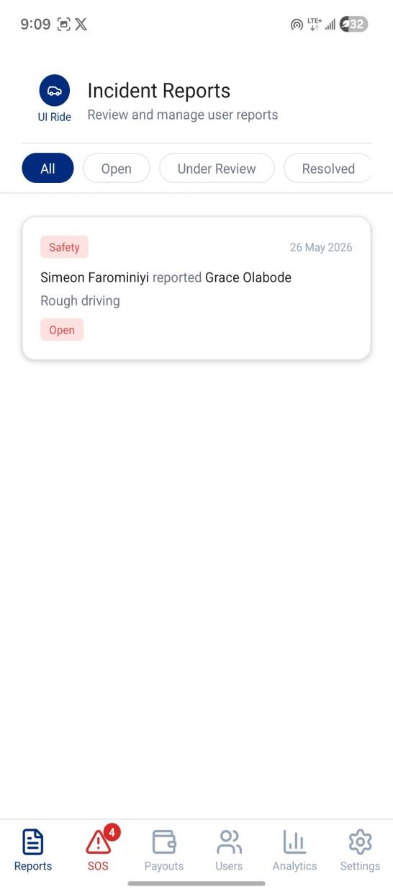 | 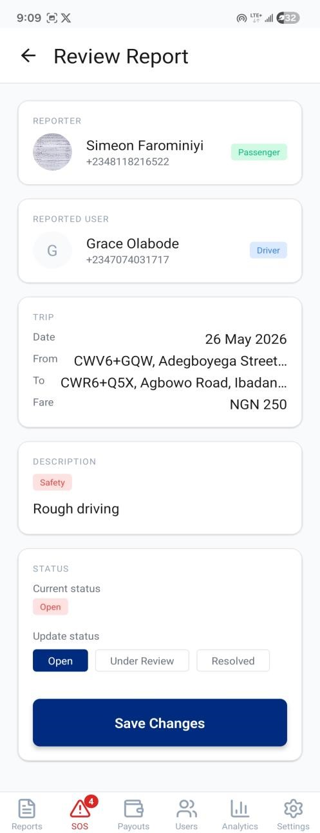

Figure 4.34: Incident reports list and review screens

4.3.4.3 Managing Emergency Alerts (SOS Tab)
- Tap the “SOS” tab. If there are active emergencies, a red badge showing the count will be visible on the tab icon.
- The Emergency list shows all alerts sorted by newest first. Each entry shows:
  - Status badge: Active (red), Responding (amber), or Resolved (green).
  - Time since the alert was sent (e.g., “5m ago”).
Reporter type (“Passenger SOS” or “Driver SOS”) and name.
d. Vehicle details preview.
- Tap any emergency entry to open the Emergency Detail modal.
In the Emergency Detail modal:
- Tap “View Location on Map” in the Location section to open Google Maps with the exact GPS coordinates of the emergency.
- In the Passenger section, the passenger's name and phone number are displayed. Tap the phone number to call the passenger directly.
- In the Driver section, the driver's name, phone number, and vehicle details are displayed. Tap the phone number to call the driver directly.
- The Ride details section shows the pickup and destination addresses, fare, and current ride status.
- Type any response notes in the Admin notes text input field to document the actions taken.
- Use the action buttons to update the emergency status:
  - “Mark as Responding”: Indicates you are actively handling this emergency.
The alert count on the SOS tab will decrease.
  - “Mark as Resolved”: Closes the emergency after it has been handled.
  - “Close”: Dismisses the modal without changing the status.
Note: All emergencies remain in the list permanently for record-keeping, even after being resolved.
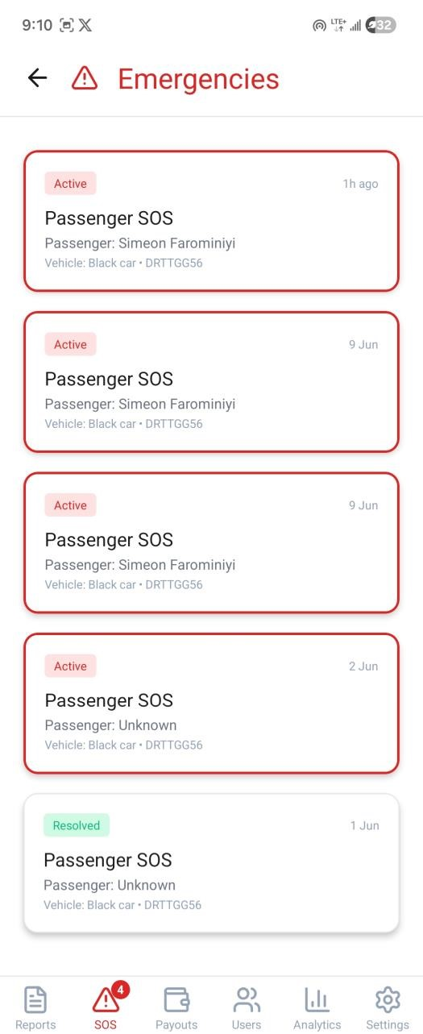 | 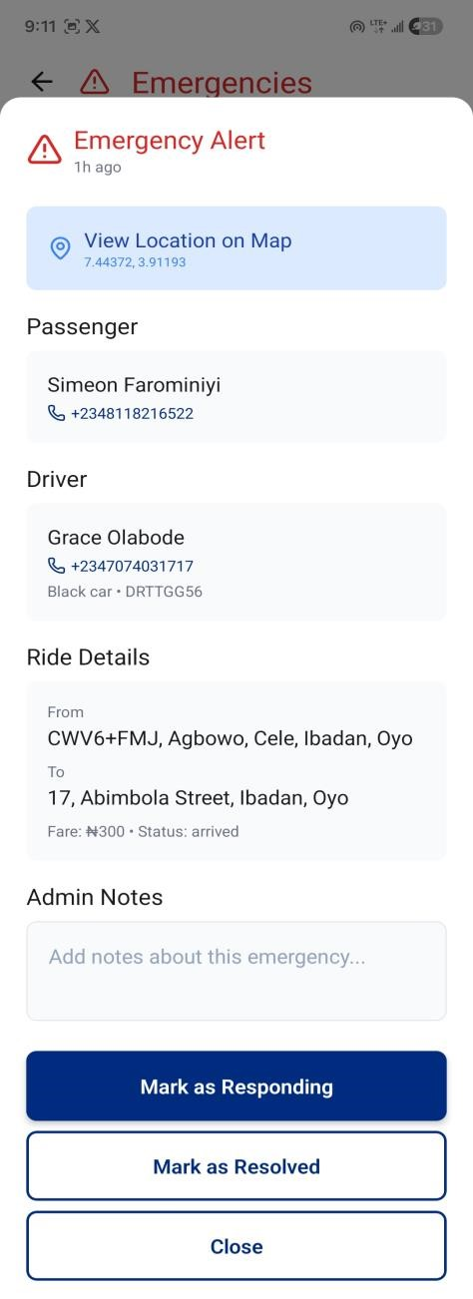

Figure 4.35: SOS screens

4.3.4.4 Managing Users
- Tap the “Users” tab.
- The Manage Users screen displays:
  - A search bar: Search users by name or phone number in real-time.
  - Filter pills: All, Passengers, Drivers, Pending (the Pending pill shows a count badge, e.g., “Pending (3)”).
User cards showing profile photo, name, phone number, type badge (Passenger or Driver), status badge (Active, Pending, or Suspended), and a “View” button.
- Tap any user card's “View” button to open the User Detail modal.
In the User Detail modal:
- For passenger accounts, you will see basic account information and status.
- For driver accounts, you will see comprehensive details including:
  - Vehicle information (type, color, plate, make, model, and year).
  - Vehicle photos in a horizontal scroll: Tap any photo to view it full-screen in a lightbox. Tap again to close.
  - License details with front and back photos (labeled): Tappable for full-screen view.
  - Bank account information (bank name, account number, and account holder name).
  - Driver statistics (average rating, total rides, and total earnings).
- For pending drivers - Approve or decline the registration:
  - Tap “Approve” to activate their account. The driver will be notified and can immediately go online.
  - Tap “Decline” to reject the application. A text input will appear for you to enter the reason for declining. Type the reason, then tap “Confirm Decline”.
The reason will be stored on the driver's account.
- For active users - Suspend an account:
  - Tap “Suspend User” (red button).
  - A confirmation dialog will appear: “Suspend [Name]? They will not be able to request rides or go online until reactivated.” Tap “Confirm” to proceed.
  - The user's status will change to “Suspended” immediately. The change is reflected on their device in real-time.
- For suspended users - Reactivate an account:
  - Tap “Reactivate User”. No confirmation dialog is required. The user's account is restored immediately.

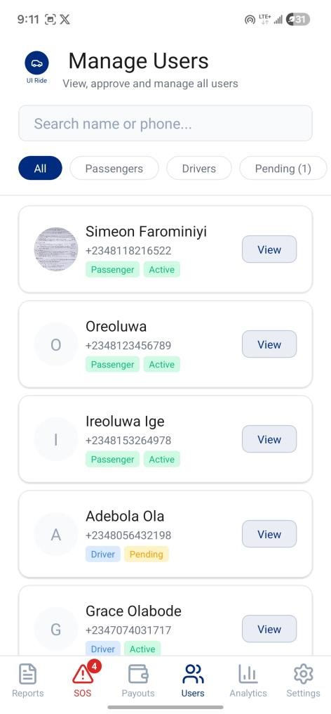 | 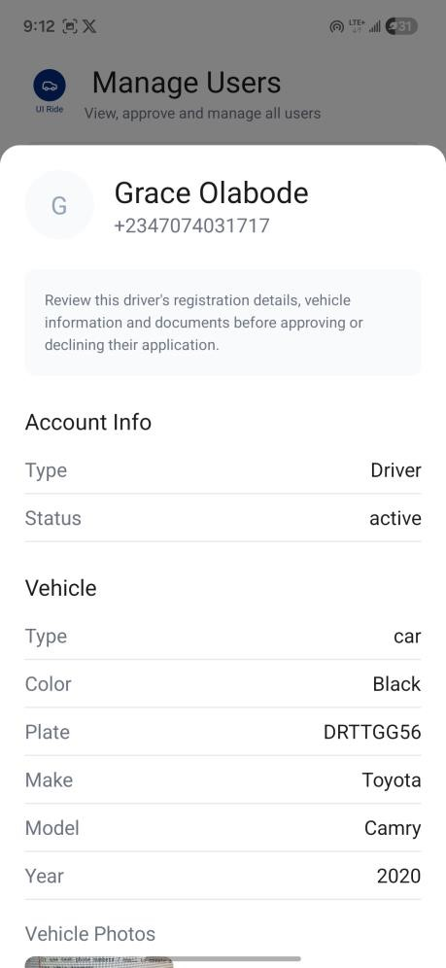

Figure 4.36: Users list with details modal

4.3.4.5 Processing Driver Payouts
- Tap the “Payouts” tab.
- Tap the “Generate Payouts” button at the top of the screen.
- A confirmation dialog will appear explaining the process. Tap “Generate” to proceed.
- The system will automatically:
    - Find all pending driver earnings.
    - Group them by driver.
    - Create payout records respecting each driver's preference: daily-preference drivers have payouts created immediately; weekly-preference drivers only have payouts created if the oldest pending earning is 7 or more days old.
- Generated payouts will appear under the Pending tab. Each payout card shows:

  - Driver photo, name, and payout preference badge (Daily or Weekly).
  - Bank details (bank name, account number, and account holder name).
  - Amount breakdown: Gross Fare (total), Commission (10%) in red, and Net Amount to Pay in green (this is the amount to transfer to the driver).
  - Period dates and trip count.
- To process a payout:
  - Manually transfer the net amount to the driver's bank account using your bank app or transfer service.
  - Tap “Processing” on the payout card to indicate the transfer has been initiated. The payout moves to the Processing tab.
  - Once you have confirmed the bank transfer is complete, tap “Mark Paid”. The payout moves to the Completed tab, and the driver receives a notification: “Your payout has been sent to your bank.”
- Use the tab filters (Pending, Processing, Completed) at the top to view payouts at different stages.
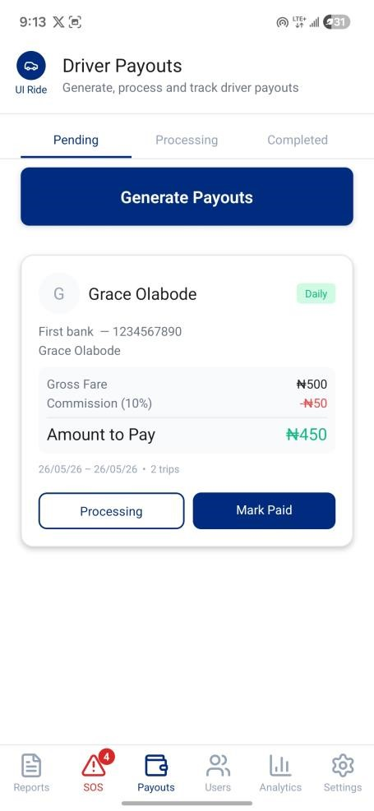 | 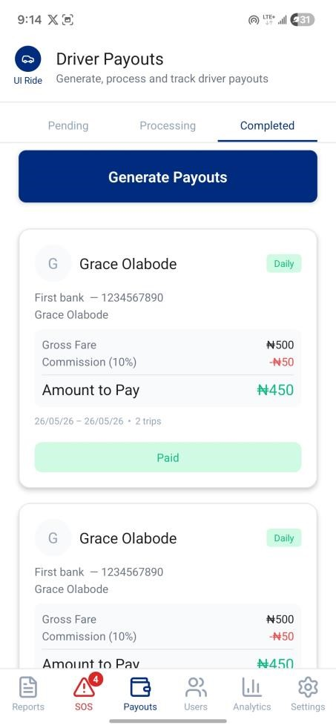

Figure 4.37: Payouts screens

4.3.4.6 Viewing Platform Analytics
- Tap the “Analytics” tab.
- Tap a period filter pill at the top (Today, This Week, This Month, or This Year) to select the reporting period. All statistics below update to reflect the chosen period.
- The screen is organised into four sections:
  - Rides: Total rides, completed, cancelled, and completion rate percentage.
  - Revenue: Total fare revenue, driver earnings (green), platform commission 10% (amber), and counts of cash vs. card payments.
  - Reports: Total reports, open count (amber), resolved count (green), and resolution rate percentage.
  - Users: Total passengers and total drivers (not period-filtered; shows lifetime totals).
- To export a report:
  - Scroll to the bottom and tap the “Export Report” button.
  - A formatted text summary of all metrics for the selected period will be generated.
  - Your device's share sheet will open, allowing you to share the report via WhatsApp, email, or save it as a note.

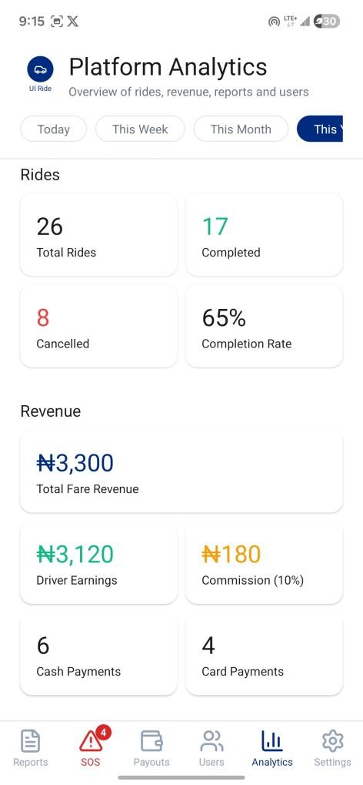 | 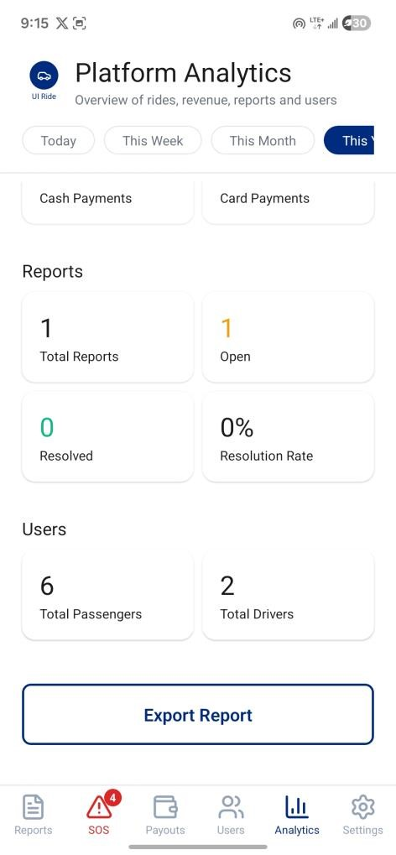
Figure 4.38: Platform Analytics Screen

4.4 Sample System Run
To illustrate the practical application of the implemented modules, the following sequence details a complete, end-to-end ride lifecycle on the UI-Ride platform within the University of Ibadan campus.
- Requesting a Ride: A student opens the passenger application while standing outside Tedder Hall. The map automatically locks onto their current GPS location. They tap the “Where are you going?” button, opening the Location Selection screen. The pickup field is auto-populated by tapping the current location button, which sets the GPS position as the pickup point. For the destination, instead of typing, the student taps the “Faculty of Science” Quick Pick chip.
- Pricing and Broadcasting: The application's Haversine algorithm instantly calculates the straight-line distance between Tedder Hall and the Faculty of Science, suggesting a baseline fare of ₦300. The student agrees and taps “Find Drivers.” The system creates a pending ride document in Firestore and begins broadcasting to all online drivers within a 5-kilometre radius.
- Receiving and Bidding: A driver parked near the Student Union Building receives the ride request. The Ride Request Modal slides up, showing the ₦300 offer. Knowing the route currently has heavy traffic, the driver decides to negotiate. They tap the counter-offer input box, type ₦400, and press “Submit Own Bid.”
- Acceptance and Connection: Back on the student's device, the Driver Offers screen updates instantly via the real-time database listener, displaying a bid card with the driver's photo, tricycle details, and the ₦400 offer. The student taps “Accept.” The system locks the ride status to “accepted,” and the driver's map updates to display a route to Tedder Hall.
- The Active Journey: As the driver navigates, their moving marker updates on the student's map every 5 seconds. Upon arriving at Tedder Hall, the driver taps “Arrived at Pickup,” sending a notification to the student. Once the student boards the tricycle, the driver taps “Start Trip.” Both screens switch to the Active Ride view, displaying the prominent red SOS button for safety.
- Completion and Payment: Upon reaching the Faculty of Science, the driver taps “Complete Trip.” The student is automatically taken to the Payment screen and selects “Pay Cash.” They hand ₦400 in cash to the driver.
- Commission Logging and Rating: The driver's Payment Collection screen displays the fare breakdown: ₦400 Gross, minus ₦40 Commission (10%), leaving ₦360 Net
Earnings. The driver taps “Confirm Cash Received.” The database records the
completed transaction. Finally, the student is presented with the Rating screen, where they leave a 5-star review for the driver's prompt service.

4.5 Summary
This chapter has comprehensively detailed the implementation of the UI-Ride application. By leveraging cross-platform technologies like React Native alongside the real-time capabilities of Firebase, the theoretical designs outlined in Chapter 3 have been successfully translated into a robust mobile solution. The chapter documented the specific hardware and software environment, provided deep explanations of the nine interconnected system modules, and outlined the rigorous unit, integration, system, and user acceptance testing conducted to ensure platform stability and reliability. The inclusion of a detailed step-by-step user manual covering all passenger, driver, and administrator workflows, supported by a practical sample system run, confirms that the application effectively addresses the unique transportation and safety needs of the University of Ibadan community.

